1. Write a JAVA Servlet Program to implement a dynamic HTML using Servlet (user name and

Password should be accepted using HTML and displayed using a Servlet).

**Project Structure**

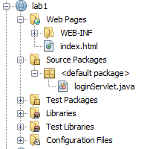

**Index.html**Top of Form

<html>

<head><title>login</title> </head>

<body>

<form action="loginServlet" method="get">

<fieldset>

<legend>Login Form</legend>

Username:<input type="text" name="username"/><br/></br>

Password: <input type="password" name="pass"/><br/></br>

<input type="submit" value="send"/>

<input type="reset" value="clear"/>

</fieldset>

</form>

</body>

</html>

**loginServlet.java**

output:

import java.io.IOException;

import java.io.PrintWriter;

import javax.servlet.ServletException;

import javax.servlet.http.HttpServlet;

import javax.servlet.http.HttpServletRequest;

import javax.servlet.http.HttpServletResponse;

public class loginServlet extends HttpServlet {

@Override

protected void doGet(HttpServletRequest request, HttpServletResponse response)

throws ServletException, IOException {

PrintWriter out = response.getWriter();

String name=request.getParameter("username");

String secretword=request.getParameter("pass");

out.println("<html>");

out.println("<head><title>Servlet</title></head>");

out.println("<body>");

out.println("<fieldset>");

out.println("<h2>You have Entered</h2>");

out.println("<p>Name: " + name + "</p>");

out.println("<p> Password: " +secretword+"</p>");

out.println("</fieldset>");

out.println("</body>");

out.println("</html>");

}

}

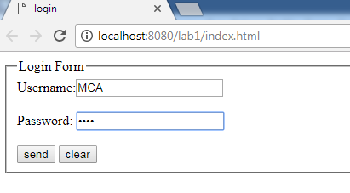

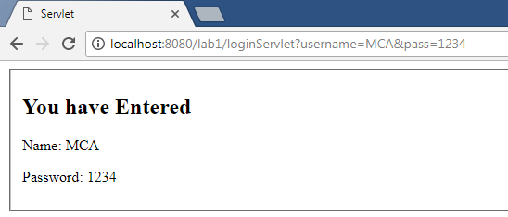

1. Write a JAVA Servlet Program to Auto Web Page Refresh

**Project Structure**

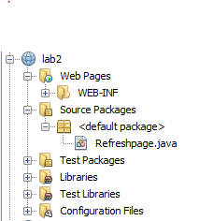

**Refresh.java**

import java.io.IOException;

import java.io.PrintWriter;

import java.util.*;

import javax.servlet.ServletException;

import javax.servlet.http.HttpServlet;

import javax.servlet.http.HttpServletRequest;

import javax.servlet.http.HttpServletResponse;

public class Refreshpage extends HttpServlet {

protected void doGet(HttpServletRequest request, HttpServletResponse response) throws ServletException, IOException {

response.setContentType("text/html;charset=UTF-8");

PrintWriter out = response.getWriter();

response.addHeader("Refresh", "3");

out.println("<h1>Auto page Refresh using Servlet: </h1>");

out.println("<br><h2>Today's date and time </h2>"+new Date());

}

}

**output**

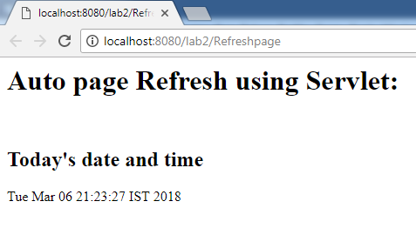

1. Write a java servlet program to implement and demonstrate get() and post() methods

**Project structure**

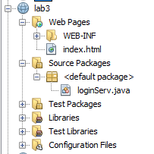

Index.html

<html>

<head>

<title>TODO supply a title</title> </head>

<body>

<form action="loginServ" method="get">

<h2> Using Get method</h2>

<h3> UserName: <input type="text" name="uname"/></h3>

<h3> Password:<input type="password" name="pwd"/></h3>

<input type="submit" value="get()"/>

<input type="reset">

<hr>

</form>

<form action="loginServ" method="post">

<h2> Using Post method</h2>

<h3> UserName: <input type="text" name="uname1"/></h3>

<h3> Password:<input type="password" name="pwd1"/></h3>

<input type="submit" value="post()"/>

<input type="reset">

<hr>

</form>

</body>

</html>

**loginServ.java**

import java.io.IOException;

import java.io.PrintWriter;

import javax.servlet.ServletException;

import javax.servlet.http.HttpServlet;

import javax.servlet.http.HttpServletRequest;

import javax.servlet.http.HttpServletResponse;

public class loginServ extends HttpServlet {

@Override

protected void doGet(HttpServletRequest request, HttpServletResponse response)

throws ServletException, IOException {

String uname = request.getParameter("uname");

String pwd=request.getParameter("pwd");

PrintWriter out=response.getWriter();

out.println("<!DOCTYPE html>");

out.println("<html>");

out.println("<head><title>Servlet loginServ</title></head>");

out.println("<body>");

out.println("<h1>Details of Get()</h1>");

out.println("<h1>username: " + uname+ "</h1>");

out.println("<h1>password: " + pwd+ "</h1>");

out.println("</body></html>");

}

@Override

protected void doPost(HttpServletRequest request, HttpServletResponse response)

throws ServletException, IOException {

String uname1 = request.getParameter("uname1");

String pwd1=request.getParameter("pwd1");

PrintWriter out=response.getWriter();

out.println("<!DOCTYPE html>");

out.println("<html>");

out.println("<head>");

out.println("<title>Servlet loginServ</title>");

out.println("</head>");

out.println("<body>");

out.println("<h1>Details of Post()</h1>");

out.println("<h1>username: " + uname1+ "</h1>");

out.println("<h1>password: " + pwd1+ "</h1>");

out.println("</body>");

out.println("</html>");

}

}

**Output**

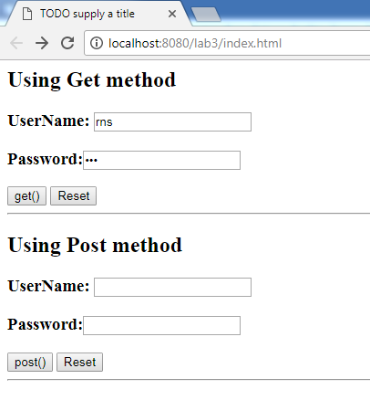

**Get request**

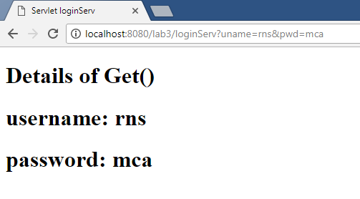

**Post request**

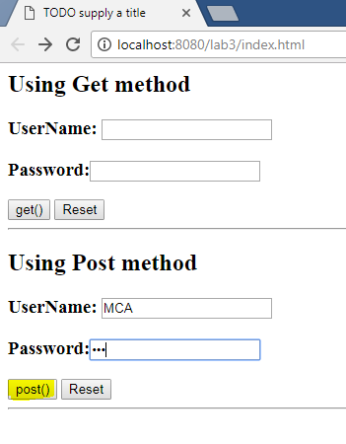

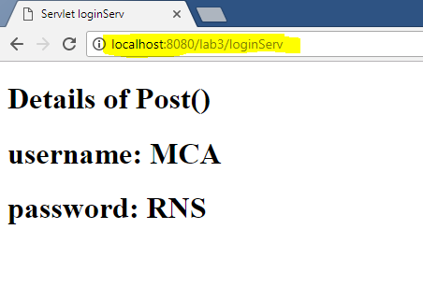

**4.** Write a JAVA Servlet Program using cookies to remember user preferences

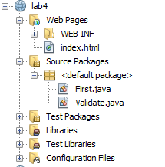

**Index.html**

<html>

<head>

<title>cookie example</title>

<meta charset="UTF-8">

<meta name="viewport" content="width=device-width">

</head>

<body>

<form method="post" action="Validate">

<fieldset>

<h2> Setting cookie </h2>

<h3>Name: <input type="text" name="user" /></h3>

<h3>Password:<input type="password" name="pass" /></h3>

<input type="submit" value="submit">

</fieldset>

</form>

</body>

</html>

**Validate.java**

import java.io.IOException;

import java.io.PrintWriter;

import javax.servlet.ServletException;

import javax.servlet.http.Cookie;

import javax.servlet.http.HttpServlet;

import javax.servlet.http.HttpServletRequest;

import javax.servlet.http.HttpServletResponse;

public class Validate extends HttpServlet {

@Override

protected void doPost(HttpServletRequest request, HttpServletResponse response)

throws ServletException, IOException {

String name = request.getParameter("user");

String pass = request.getParameter("pass");

if(pass.equals("1234"))

{

Cookie ck = new Cookie("username",name);

response.addCookie(ck);

response.sendRedirect("First");

}

}

}

**First.java**

import java.io.IOException;

import java.io.PrintWriter;

import javax.servlet.ServletException;

import javax.servlet.http.Cookie;

import javax.servlet.http.HttpServlet;

import javax.servlet.http.HttpServletRequest;

import javax.servlet.http.HttpServletResponse;

public class First extends HttpServlet {

protected void doGet(HttpServletRequest request, HttpServletResponse response)

throws ServletException, IOException {

PrintWriter out = response.getWriter();

//read cookie

Cookie[] cks = request.getCookies();

out.println("Welcome "+cks[0].getValue());

}

}

**Output:**

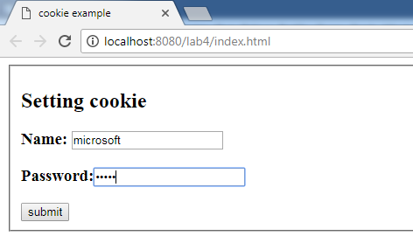

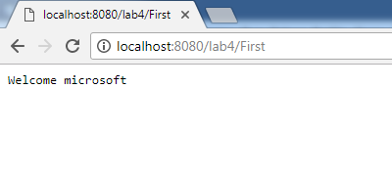

**5.** Write a JAVA Servlet program to track HttpSession by accepting user name and password using

HTML and display the profile page on successful login.

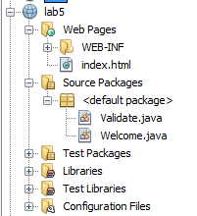

**Index.html**

<html>

<head>

<title>setting session</title>

</head>

<body>

<form method="post" action="Validate">

<fieldset>

<h2> Setting session </h2>

<h3>Name: <input type="text" name="user" /></h3>

<h3>Password:<input type="password" name="pass" /></h3>

<input type="submit" value="submit">

</fieldset>

</form>

</body>

</html>

**Validate.java**

import java.io.IOException;

import java.io.PrintWriter;

import javax.servlet.ServletException;

import javax.servlet.http.HttpServlet;

import javax.servlet.http.HttpServletRequest;

import javax.servlet.http.HttpServletResponse;

import javax.servlet.http.HttpSession;

public class Validate extends HttpServlet {

protected void doPost(HttpServletRequest request, HttpServletResponse response)

throws ServletException, IOException {

String name = request.getParameter("user");

String pass = request.getParameter("pass");

if(pass.equals("1234"))

{

//creating a session

HttpSession session = request.getSession();

session.setAttribute("user", name);

response.sendRedirect("Welcome");

}

}

}

**Welcome.java**

import java.io.IOException;

import java.io.PrintWriter;

import javax.servlet.ServletException;

import javax.servlet.http.HttpServlet;

import javax.servlet.http.HttpServletRequest;

import javax.servlet.http.HttpServletResponse;

import javax.servlet.http.HttpSession;

public class Welcome extends HttpServlet {

protected void doGet(HttpServletRequest request, HttpServletResponse response)

throws ServletException, IOException {

PrintWriter out = response.getWriter();

// getting session

HttpSession session = request.getSession();

String user = (String)session.getAttribute("user");

out.println("Hello "+user);

}

}

Output

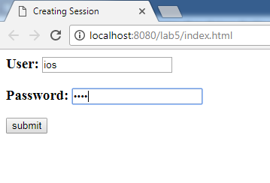

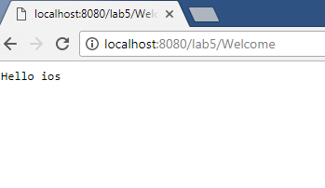

6. Write a JAVA JSP Program which uses jsp:include and jsp:forward action to display a Webpage.

**Project Structure:**

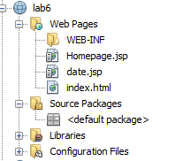

Index.html

<!DOCTYPE html>

<html>

<head>

<meta http-equiv="Content-Type" content="text/html; charset=UTF-8">

<title>JSP Page</title></head>

<body>

<form action="Homepage.jsp" method="post">

<h2> Enter your birth date </h2>

Date: <input type="text" name="day"/>

<input type="submit" value="submit"/>

<input type="reset" value="clear"/>

</form>

</body>

</html>

Homepage.jsp

|  |
| --- |
| <%@page import="java.util.Date"%>  <%@page import="java.util.GregorianCalendar"%>  <%@page import="java.util.Calendar"%>  <!DOCTYPE html>  <html>  <head>  <meta http-equiv="Content-Type" content="text/html; charset=UTF-8">  <title>Homepage</title>  </head>  <body>  <h1>Happy Birthday</h1>  <%  Date date = new Date();  int udate = Integer.parseInt(request.getParameter("day"));  %>  <%if(udate==(date.getDate())){ %>  <jsp:include page="date.jsp"/>  <%}else{ %>  <jsp:forward page="date.jsp"/>    <%}%>  </body> </html> |

|  |
| --- |
| <%@page contentType="text/html" pageEncoding="UTF-8"%>  <!DOCTYPE html>  <html>  <head>  <meta http-equiv="Content-Type" content="text/html; charset=UTF-8">  <title>welcome</title> </head>  <body>  <h1>**Welcome to home page**</h1>  </body>  </html> |

**date.jsp**

output

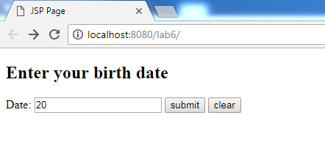

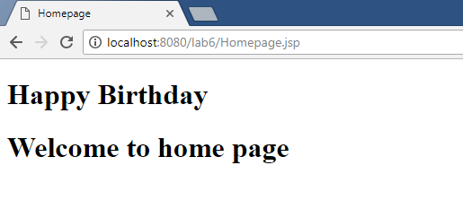

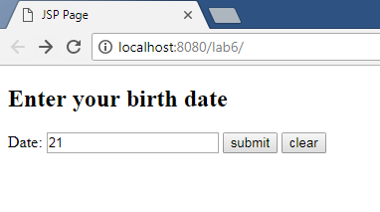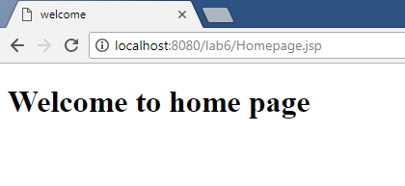

7. Write a JAVA JSP program which uses <jsp:pulgin> tag to run an applet.

**Project Structure**

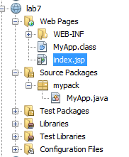

|  |
| --- |
| ***Index.jsp***  <%@page contentType="text/html" pageEncoding="UTF-8"%>  <!DOCTYPE html>  <html>  <head>  <meta http-equiv="Content-Type" content="text/html; charset=UTF-8">  <title>JSP Page</title>  </head>  <body>  <h1>Applet Demo</h1>  <jsp:plugin type="applet" code="MyApp.class" height="500" codebase="mypack" width="500">  <jsp:fallback>  unable to load  </jsp:fallback>  </jsp:plugin>  <h4><font color=red>  The above applet is loaded using the Java Plugin from a jsp page using the plugin tag  </font>  </body>  </html> |

**MyApp.java**

|  |
| --- |
| package mypack;  import java.applet.Applet;  import java.awt.Color;  import java.awt.Graphics;  public class MyApp extends Applet {  public void init() {  // TODO start asynchronous download of heavy resources  }  public void paint(Graphics g){  setBackground(Color.red);  setForeground(Color.blue);  g.drawString("hello from jsp", 100, 200);  }  } |

Output:

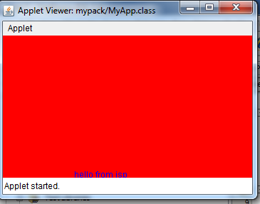

8. Write a JAVA JSP Program to get student information through a HTML and create a JAVA Bean

class, populate Bean and display the same information through another JSP

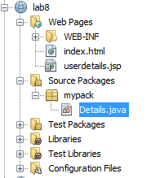

**Index.html**

<!DOCTYPE html>

<html>

<head>

<title>Student Info</title>

<meta charset="UTF-8">

<meta name="viewport" content="width=device-width">

</head>

<body>

<form action="userdetails.jsp" method="post">

<center><h2> Enter the student details </h2>

<p> Name: <input type="text" name="name"><br> </p>

<p>USN: <input type="text" name="usn"><br> </p>

<p>Branch: <input type="text" name="branch"><br></p>

<input type="submit" value="register"> </center>

</form>

</body>

</html>

**userdetails.jsp**

<!DOCTYPE html>

<html>

<head>

<meta http-equiv="Content-Type" content="text/html; charset=UTF-8">

<title>JSP Page</title>

</head>

<body>

<jsp:useBean id="userinfo" class="mypack.Details">

</jsp:useBean>

<jsp:setProperty property="*" name="userinfo" />

<strong> Entered Details are below: </strong>

<p>

<jsp:getProperty property="name" name="userinfo"/><br>

<jsp:getProperty property="usn" name="userinfo"/><br>

<jsp:getProperty property="branch" name="userinfo" /><br>

</p>

</body>

</html>

**Details.java**

package mypack;

import java.io.Serializable;

public class Details implements Serializable{

private String name;

public String getName() {

return name;

}

public void setName(String name) {

this.name = name;

}

public String getBranch() {

return branch;

}

public void setBranch(String branch) {

this.branch = branch;

}

public String getUsn() {

return usn;

}

public void setUsn(String usn) {

this.usn = usn;

}

private String branch;

private String usn;

}

**Output**

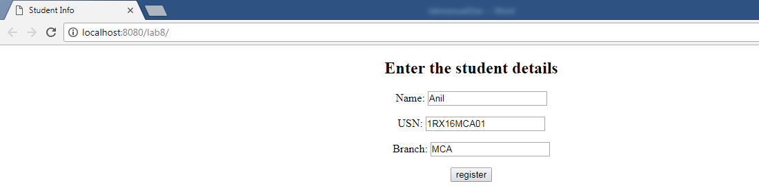

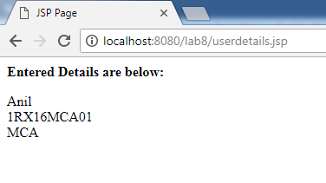

9. Write a JSP program to implement all the attributes of page directive tag.

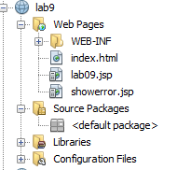

Index.html

|  |
| --- |
| <html>  <head>  <title>page attribute</title>  <meta charset="UTF-8">  <meta name="viewport" content="width=device-width">  </head>  <body>  <h2>Read two value to divide</h2>  <form action="lab09.jsp">  Enter First Value:<input type="text" name="val1"/><br>  Enter Second Value:<input type="text" name="val2"/><br>  <input type="submit" value="Calculate"/>  </form>  </body>  </html> |

Lab09.jsp

|  |
| --- |
| **<%@page import="java.util.Date"**  **contentType="text/html"**  **pageEncoding="UTF-8"**  **session="true"**  **buffer="16kb"**  **autoFlush="true"**  **isThreadSafe="true"**  **isELIgnored="false"**  **extends="org.apache.jasper.runtime.HttpJspBase"**  **info="Lab 10: demo of all page directive" language="java"**  **errorPage="showerror.jsp"**  **%>**  <!DOCTYPE html>  <html>  <head>  <title>JSP Page</title> </head>  <%! int a, b;  Date d=new Date();%>  <body>  <h2>Welcome! Today is <%= d.getDate()%></h2>  <%  String str1=request.getParameter("val1");  String str2=request.getParameter("val2");  a=Integer.parseInt(str1);  b=Integer.parseInt(str2);%>  <h2>Using Expression Language</h2>  A= ${param.val1}<br>  B= ${param.val2}<br>  <h3>Result: <%= a / b %></h3>  </body>  </html> |

showerror.jsp

|  |
| --- |
| **<%@page isErrorPage="true"%>**  <!DOCTYPE html> <html>  <head>  <title>JSP Page</title> </head>  <body>  **<h3>Sorry an exception occured!</h3>**  **<h2>The exception is: <%= exception %>** </h2> </body>  </html> |

Output:

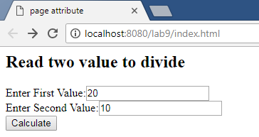

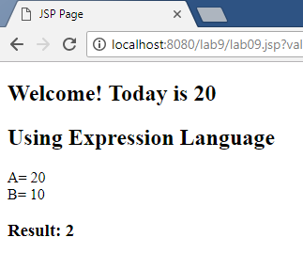

10. Write a JAVA Program to insert data into Student DATA BASE and retrieve info based on particular queries(For example update, delete, search etc…)

|  |
| --- |
| import java.sql.*;  import java.util.Scanner;  public class Student  {  Connection con;  public void establishConnection()throws ClassNotFoundException,SQLException  {  Class.forName("com.mysql.jdbc.Driver");  con=DriverManager.getConnection("jdbc:mysql://localhost:3306/studentlogin","root","rnsit");  }  public void sInsert(String usn, String name, String dept)throws ClassNotFoundException, SQLException  {  PreparedStatement pst=null;  establishConnection();  try  {  if(con!=null)  {  pst=con.prepareStatement("insert into student values(?,?,?)");  pst.setString(1, usn);  pst.setString(2,name);  pst.setString(3,dept);  int i=pst.executeUpdate();  if(i==1)  {  System.out.println("Record inserted successfully");  } } }  catch(SQLException e)  {  System.err.println(e.getMessage());  }  finally  {  pst.close();  con.close();  } }  public void sSelect(String usn)throws ClassNotFoundException,SQLException  {  PreparedStatement pst=null;  ResultSet res;  establishConnection();  try  {  if(con!=null)  {  pst=con.prepareStatement("select * from student where usn=?");  pst.setString(1, usn);  res=pst.executeQuery();  if(res.next())  {  System.out.println("USN= "+res.getString(1)+"\tName="+ res.getString(2)+ "\tDepartment= "+res.getString(3));  } } }  finally  {  pst.close();  con.close();  } }  public void sUpdate(String usn, String name, String dept)throws ClassNotFoundException, SQLException  {  PreparedStatement pst=null;  establishConnection();  try  {  if(con!=null)  {  pst=con.prepareStatement("update student set name=?,dept=? where usn=?");  pst.setString(1, name);  pst.setString(2,dept);  pst.setString(3,usn);  int i=pst.executeUpdate();  System.out.println(i);  if(i==1)  {  System.out.println("Record updated successfully");  } } }  finally  {  pst.close();  con.close();  } }  public void sDelete(String usn)throws ClassNotFoundException, SQLException  {  PreparedStatement pst=null;  establishConnection();  try  {  if(con!=null)  {  pst=con.prepareStatement("delete from student where usn=?");  pst.setString(1, usn);  int i=pst.executeUpdate();  if(i==1)  {  System.out.println("Record deleted successfully");  } } }  catch(SQLException e)  {  System.err.println(e.getMessage());  }  finally  {  pst.close();  con.close();  } }  public void viewAll( )throws ClassNotFoundException, SQLException  {  PreparedStatement pst=null;  ResultSet res;  establishConnection();  try  {  if(con!=null)  {  pst=con.prepareStatement("select * from student");  res=pst.executeQuery();  while(res.next())  {  System.out.println("USN= "+res.getString(1)+"\tName="+res.getString(2)+"\tDepartment= "+res.getString(3));  } } }  catch(SQLException e)  {  System.err.println(e.getMessage());  }  finally  {  pst.close();  con.close();  } }  public static void main(String[] a) throws ClassNotFoundException, SQLException  {  Student std=new Student();  String usn,name,dept;  Scanner sc=new Scanner(System.in);  while(true)  {  System.out.println("Operations on Student table");  System.out.println("1.Insert\n2.Select\n3.Update\n4.Delete\n5.View All\n6.Exit");  System.out.println("select the operation");  switch(sc.nextInt())  {  case 1: System.out.println("Enter USN to insert");  usn=sc.next();  System.out.println("Enter Name to insert");  name=sc.next();  System.out.println("Enter Deaprtment to insert");  dept=sc.next();  std.sInsert(usn, name, dept);  break;  case 2: System.out.println("Enter USN to select");  usn=sc.next();  std.sSelect(usn);  break;  case 3: System.out.println("Enter USN to update");  usn=sc.next();  System.out.println("Enter Name to update");  name=sc.next();  System.out.println("Enter department to update");  dept=sc.next();  std.sUpdate(usn, name, dept);  break;  case 4: System.out.println("Enter USN to delete");  usn=sc.next();  std.sDelete(usn);  break;  case 5: std.viewAll();  break;  case 6: System.exit(0);  default: System.out.println("Invalid operation");  break;  }  }  }  } |

11. An EJB application that demonstrates Session bean

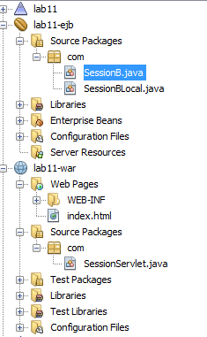

**SessionB.java**

package com;

import javax.ejb.Stateless;

@Stateless

public class SessionB implements SessionBLocal {

@Override

public int Square(int side) {

**return side*side;**

}

}

**SessionBLocal**

package com;

import javax.ejb.Local;

@Local

public interface SessionBLocal {

int Square(int side);

}

**index.html**

<!DOCTYPE html>

<html>

<head>

<title>lab11</title>

<meta charset="UTF-8">

<meta name="viewport" content="width=device-width">

</head>

<body>

<form action="SessionServlet">

Enter the number:

<input type="text" name="num"/><br>

<input type="submit"/>

</form>

</body>

</html>

**SessionServlet.java**

package com;

import java.io.IOException;

import java.io.PrintWriter;

import javax.ejb.EJB;

import javax.servlet.ServletException;

import javax.servlet.http.HttpServlet;

import javax.servlet.http.HttpServletRequest;

import javax.servlet.http.HttpServletResponse;

public class SessionServlet extends HttpServlet {

@EJB

private SessionBLocal sessionB;

@Override

protected void doGet(HttpServletRequest request, HttpServletResponse response)

throws ServletException, IOException {

**PrintWriter out=response.getWriter();**

**int i, result;**

**i=Integer.parseInt(request.getParameter("num"));**

**result=sessionB.Square(i);**

**out.println("the result "+result);**

}

}

Output:

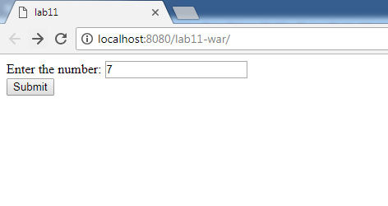

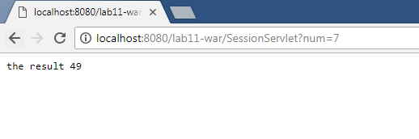

**12. An EJB application that demonstrates MDB (with appropriate business logic).**

**Project Structure**

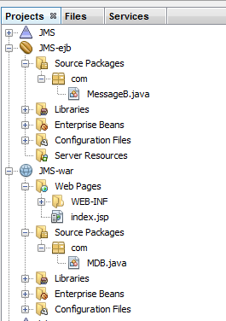

***MessageB.java***

|  |
| --- |
| package com;  import java.util.logging.Level;  import java.util.logging.Logger;  import javax.ejb.ActivationConfigProperty;  import javax.ejb.MessageDriven;  import javax.jms.JMSException;  import javax.jms.Message;  import javax.jms.MessageListener;  import javax.jms.TextMessage;  @MessageDriven(mappedName = "jms/destlab12", activationConfig = {  @ActivationConfigProperty(propertyName = "destinationType", propertyValue = "javax.jms.Queue")  })  public class MessageB implements MessageListener {    public MessageB() {  }    @Override  public void onMessage(Message message) {  TextMessage t=null;  t=(TextMessage) message;  try {  System.out.println(t.getText());  } catch (JMSException ex) {  Logger.getLogger(MessageB.class.getName()).log(Level.SEVERE, null, ex);  }  }    } |

***index.jsp***

|  |
| --- |
| <%@page contentType="text/html" pageEncoding="UTF-8"%>  <!DOCTYPE html>  <html>  <head>  <meta http-equiv="Content-Type" content="text/html; charset=UTF-8">  <title>JSP Page</title>  </head>  <body>  <form action="MDB">  Type your message :<input type="text" name="msg"/><br>  <input type="submit"/>  </form>    </body>  </html> |

***MDB.java***

|  |
| --- |
| package com;  import java.io.IOException;  import java.io.PrintWriter;  import java.util.logging.Level;  import java.util.logging.Logger;  import javax.annotation.Resource;  import javax.jms.Connection;  import javax.jms.ConnectionFactory;  import javax.jms.JMSException;  import javax.jms.Message;  import javax.jms.MessageProducer;  import javax.jms.Queue;  import javax.jms.Session;  import javax.jms.TextMessage;  import javax.servlet.ServletException;  import javax.servlet.http.HttpServlet;  import javax.servlet.http.HttpServletRequest;  import javax.servlet.http.HttpServletResponse;  public class MDB extends HttpServlet {  @Resource(mappedName = "jms/destlab12")  private Queue destlab12;  @Resource(mappedName = "jms/lab12")  private ConnectionFactory lab12;    @Override  protected void doGet(HttpServletRequest request, HttpServletResponse response)  throws ServletException, IOException {  PrintWriter out=response.getWriter();  String m=request.getParameter("msg");  try {  sendJMSMessageToDestlab12(m);  } catch (JMSException ex) {  Logger.getLogger(MDB.class.getName()).log(Level.SEVERE, null, ex);  }  out.println("check output in server log");    }  private Message createJMSMessageForjmsDestlab12(Session session, Object messageData) throws JMSException {  // TODO create and populate message to send  TextMessage tm = session.createTextMessage();  tm.setText(messageData.toString());  return tm;  }  private void sendJMSMessageToDestlab12(Object messageData) throws JMSException {  Connection connection = null;  Session session = null;  try {  connection = lab12.createConnection();  session = connection.createSession(false, Session.AUTO_ACKNOWLEDGE);  MessageProducer messageProducer = session.createProducer(destlab12);  messageProducer.send(createJMSMessageForjmsDestlab12(session, messageData));  } finally {  if (session != null) {  try {  session.close();  } catch (JMSException e) {  Logger.getLogger(this.getClass().getName()).log(Level.WARNING, "Cannot close session", e);  }  }  if (connection != null) {  connection.close();  }  }  }  } |

**Output**

1. **Right Click on JMS** 

**Select clean and build**

1. **Right Click on JMS** 

**Deploy**

1. **Right Click on JMS**

**Run**

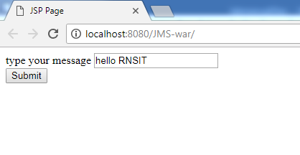

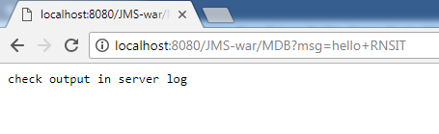

**Go back to Netbeans->GlassFish Server 4.0**

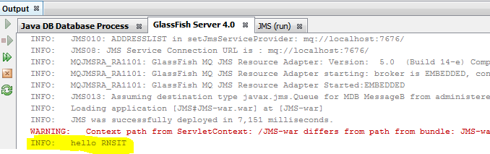

**13.** An EJB application that demonstrates persistence (with appropriate business logic).

**Project Structure**

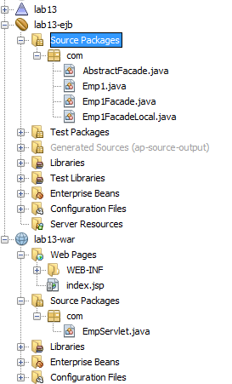

**EMP1Facade.java**

|  |
| --- |
| package com;  import javax.ejb.Stateless;  import javax.persistence.EntityManager;  import javax.persistence.PersistenceContext;  @Stateless  public class Emp1Facade extends AbstractFacade<Emp1> implements Emp1FacadeLocal {  @PersistenceContext(unitName = "lab13-ejbPU")  private EntityManager em;  @Override  protected EntityManager getEntityManager() {  return em;  }  public Emp1Facade() {  super(Emp1.class);  }  ***public void addEmp(String eid, String ename)***  ***{***  ***Emp1 e=new Emp1();***  ***e.setEid(eid);***  ***e.setEname(ename);***  ***create(e);***  ***}***  } |

**Emp1FacadeLocal.java**

|  |
| --- |
| package com;  import java.util.List;  import javax.ejb.Local;  @Local  public interface Emp1FacadeLocal {  void create(Emp1 emp1);  void edit(Emp1 emp1);  void remove(Emp1 emp1);  Emp1 find(Object id);  List<Emp1> findAll();  List<Emp1> findRange(int[] range);  int count();  ***void addEmp(String eid, String ename);***  **}** |

***index.jsp***

|  |
| --- |
| <%@page contentType="text/html" pageEncoding="UTF-8"%>  <!DOCTYPE html>  <html>  <head>  <meta http-equiv="Content-Type" content="text/html; charset=UTF-8">  <title>JSP Page</title>  </head>  <body>  <form action="EmpServlet" method="GET">  <b>Employee Form</b><br/><br/>  Emp Id: <input type="text" name="id"/><br/>  Name: <input type="text" name="name"/><br/>  <input type="submit" value="Add"/>  </form>  </body>  </html> |

**EmpServlet.java**

|  |
| --- |
| package com;  import java.io.IOException;  import java.io.PrintWriter;  import javax.ejb.EJB;  import javax.servlet.ServletException;  import javax.servlet.http.HttpServlet;  import javax.servlet.http.HttpServletRequest;  import javax.servlet.http.HttpServletResponse;  public class EmpServlet extends HttpServlet {  @EJB  private Emp1FacadeLocal emp1Facade;  @Override  protected void doGet(HttpServletRequest request, HttpServletResponse response)  throws ServletException, IOException {  PrintWriter out=response.getWriter();  String eid=request.getParameter("id");  String ename=request.getParameter("name");  emp1Facade.addEmp(eid, ename);  out.println("<b> Employee Id: " + eid + "</b><br/>");  out.println("<b> Employee Ename: " + ename + "</b><br/><br/>  <b>Added to database</b>");  }  } |

**Output:**

**1.Clean and Build**

**2. Deploy**

**3. Run**

